- what defines a meaning of the concept? Does it have a meaning by itself, or rather even its core meaning can only be defined by its relationships (contexts)?
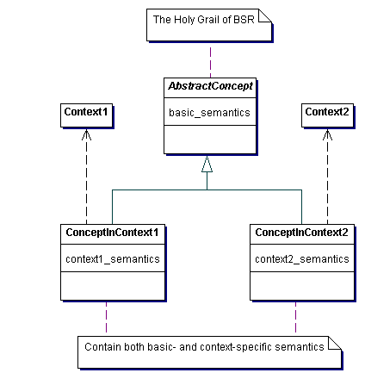
Figure 1 It is possible to define semantics of a concept independently of any contexts.
- What I’m inclined to believe is that there are no abstract semantic units – a semantic unit (a concept) is always defined by one or more contexts, starting from something I call a “community context”, which is (in its widest sense) dependent on human perception, language and life experience.
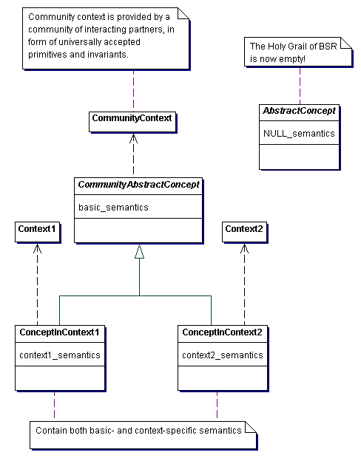
Figure 2 The semantics of a concept ALWAYS depends on some context.
- Each of the concepts relates to many others (which, in fact, form a context around it!). So, we should be able to define the concept by its relationships, dependencies and properties.
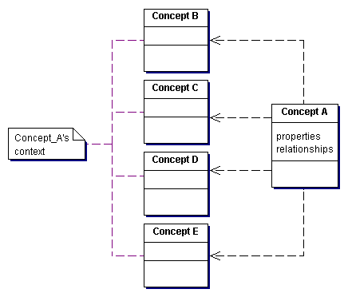
Figure 3 Context defines the concept.
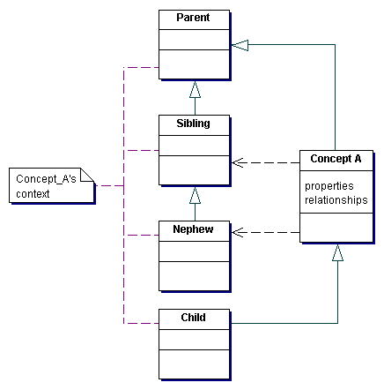
Figure 4 Context consists of relationships and dependencies.
- Concept relationships and dependencies (i.e. the context) may be categorized. However, simple categorization is a tree structure, whereas many contexts are graphs. Then, how to best represent the context in a structured way?
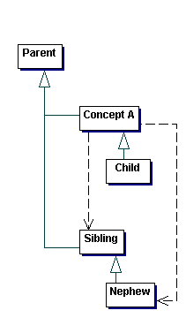
Figure 5 Can most of the contexts be represented by simple categorization?
- The mapping between groups of concepts belonging to their own different contexts: I put forward the following thesis:
A successful mapping between concepts belonging to different contexts allows them to play the role of corresponding concepts in another context.
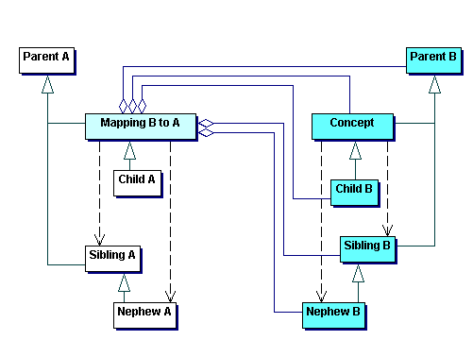
Figure 6 Mapping between concepts belonging to different contexts.
- If this thesis can be proved, then we should have a solid basis for working out the methodology for building the semantic mappings. In such case, the task of mapping could be reduced to mapping of properties and relationships.

